CAPSTONE ( CUSTOMER ACCOUNT TRACKER REST API)

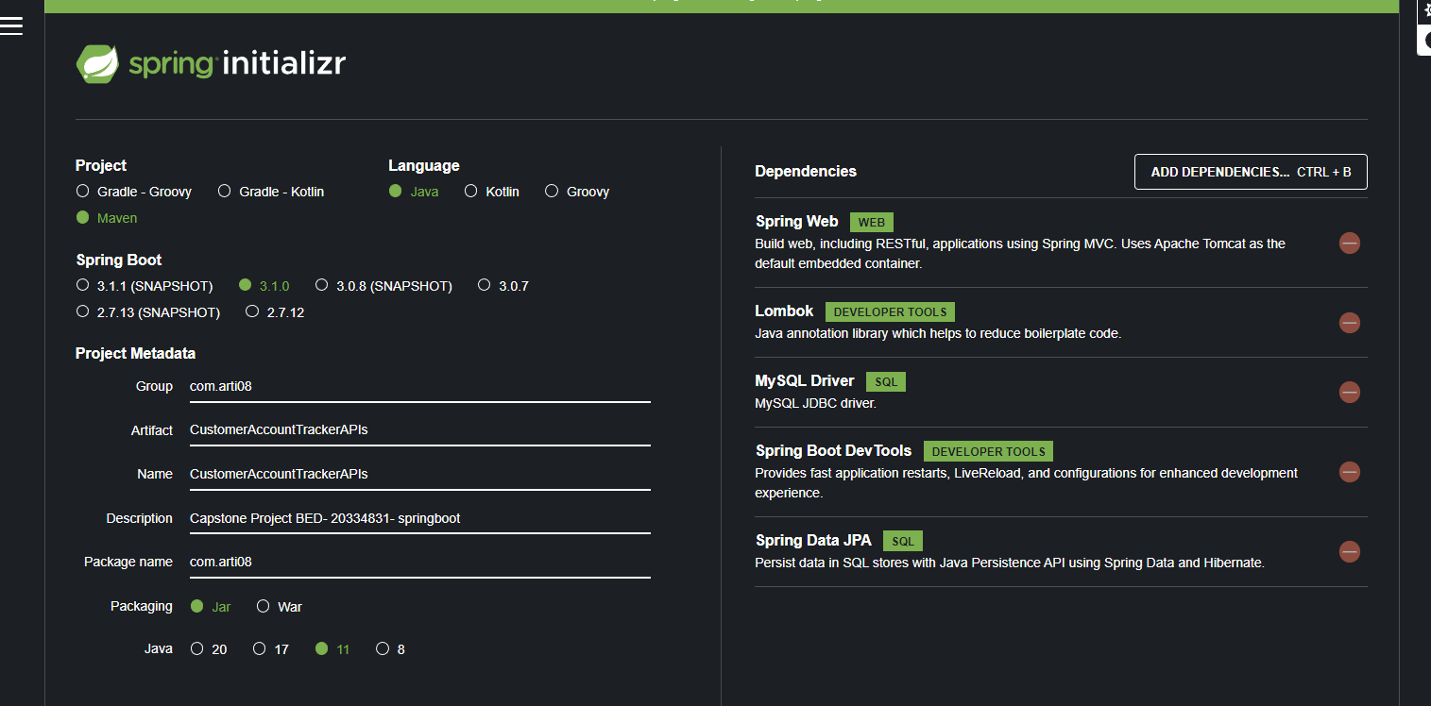

Create database:

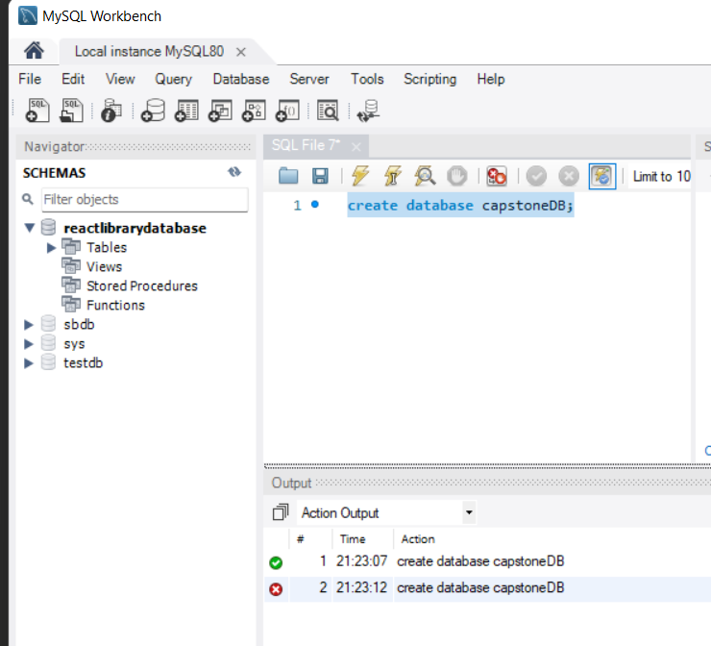

SHOW TABLES:

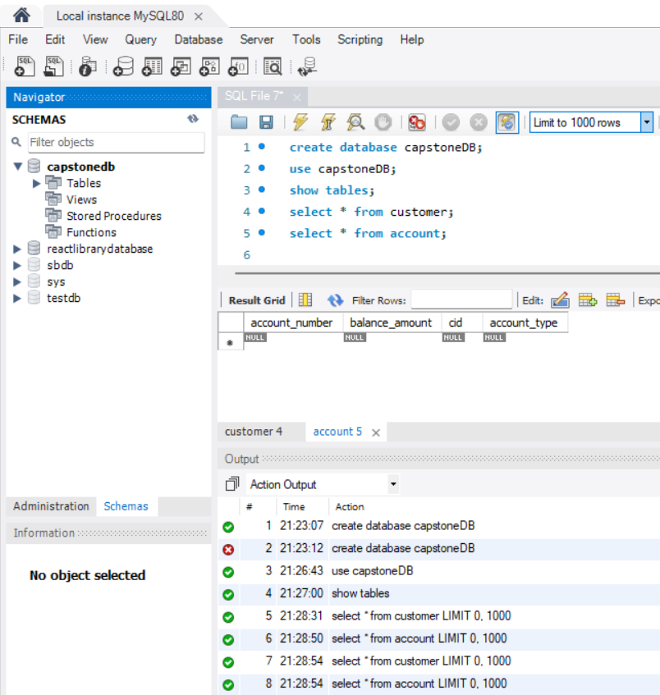

{

    "accountType":"Saving",

    "balanceAmount":2000,

    "customer":{

        "firstName":"Arti",

        "lastName":"D",

        "address":"pune",

        "contactNumber":1234567890,

        "aadharNo":"ArtiAdhar"

    }

}

{

    "accountType":"Saving",

    "balanceAmount":2000,

    "customer":{

        "firstName":"Vaishali",

        "lastName":"B",

        "address":"Latur",

        "contactNumber":7865456735,

        "aadharNo":"vAdhar"

    }

}

{

    "accountType":"salary",

    "balanceAmount":5000,

    "customer":{

        "firstName":"shital",

        "lastName":"k",

        "address":"kerala",

        "contactNumber":4534234555,

        "aadharNo":"SAdhar"

    }

}

1. ADD ACCOUNT

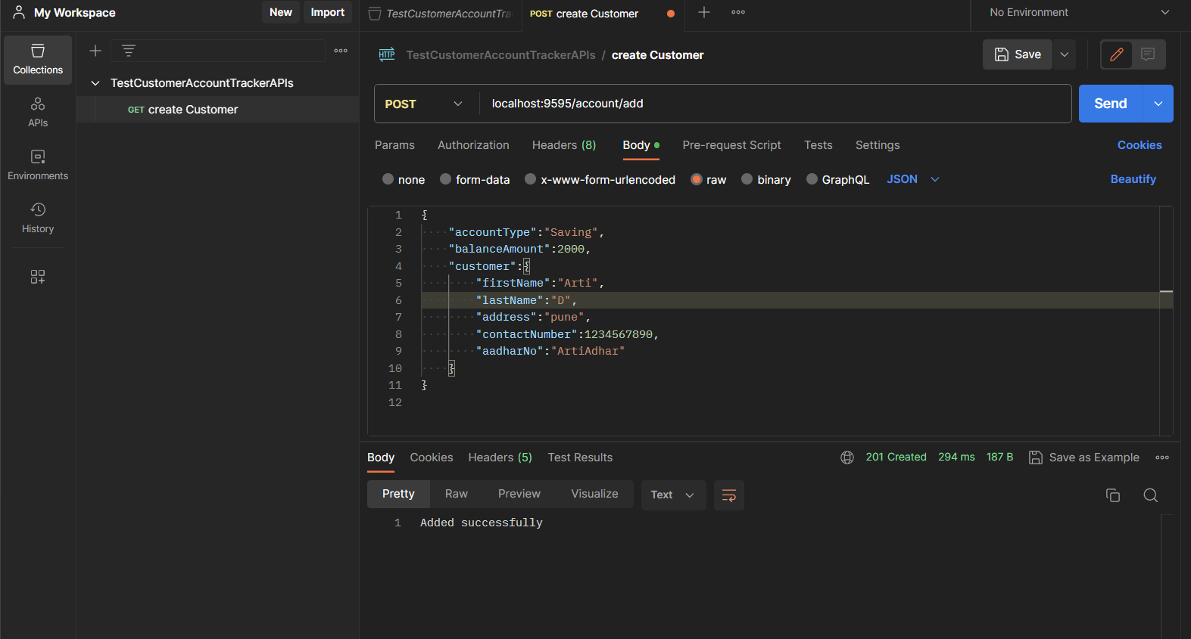

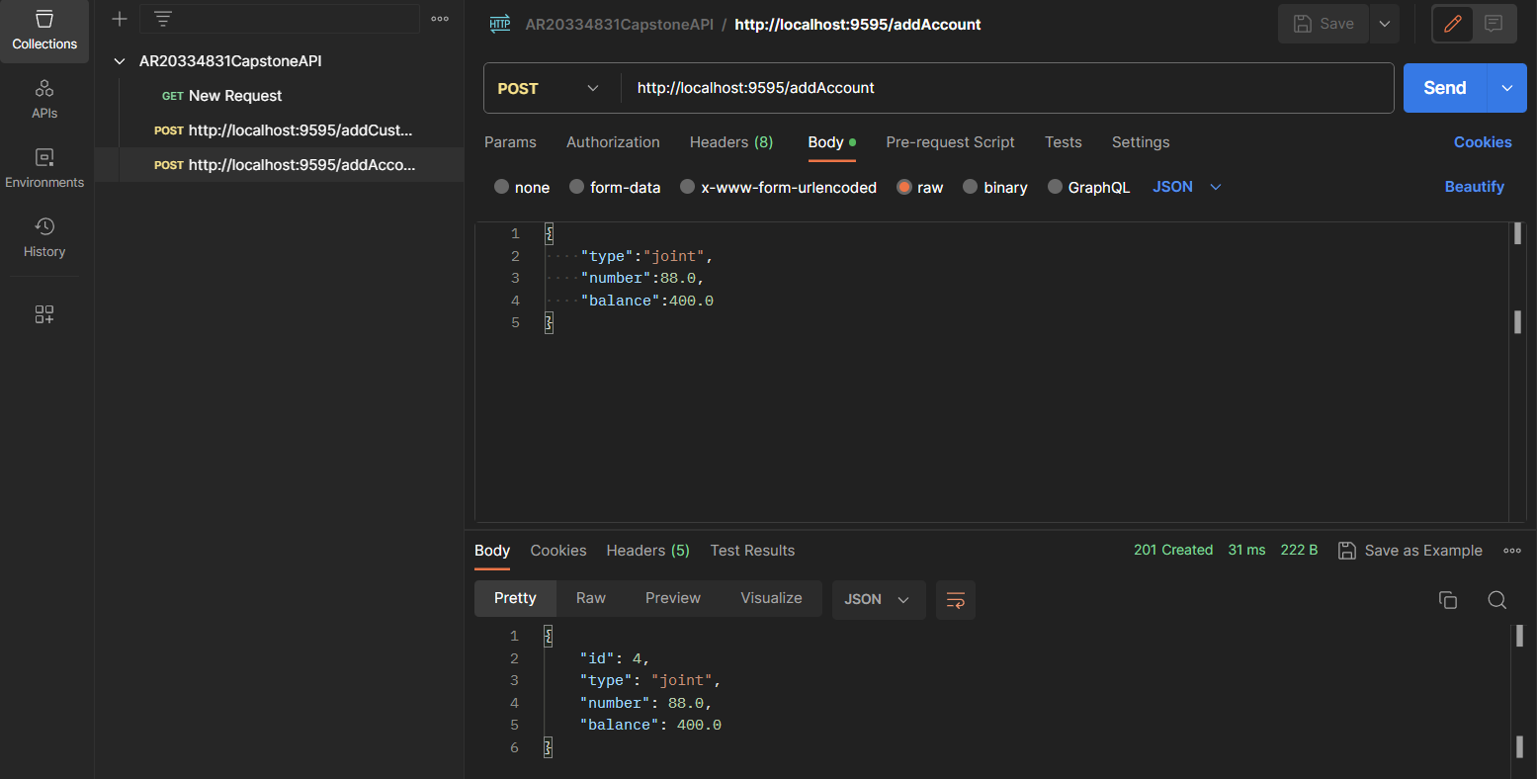

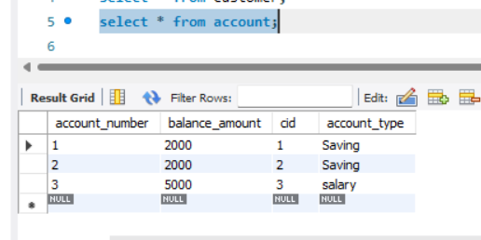

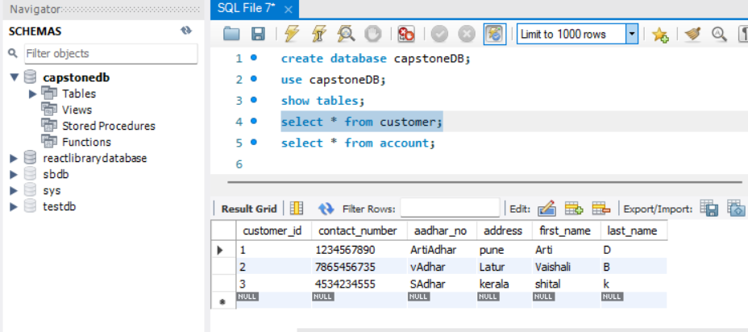

1. GET ALL ACCOUNTS

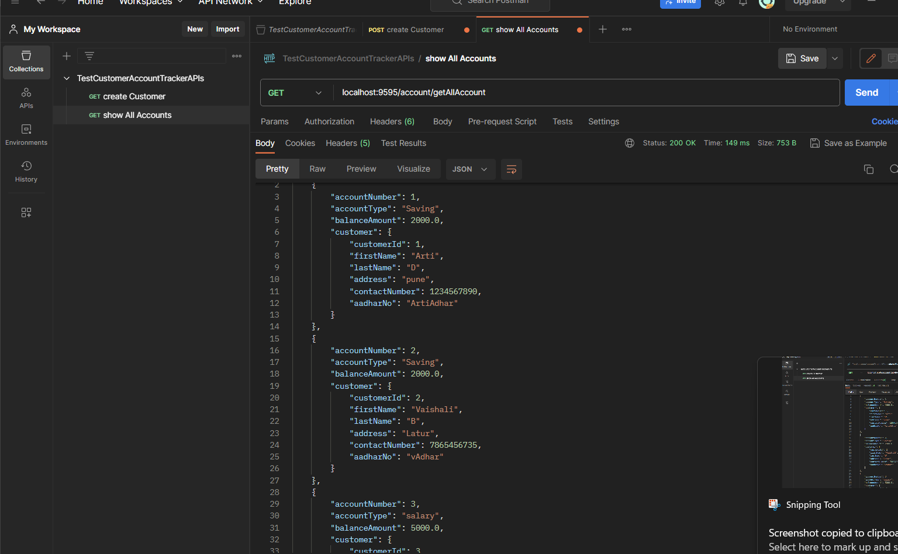

1. FIND BY ID

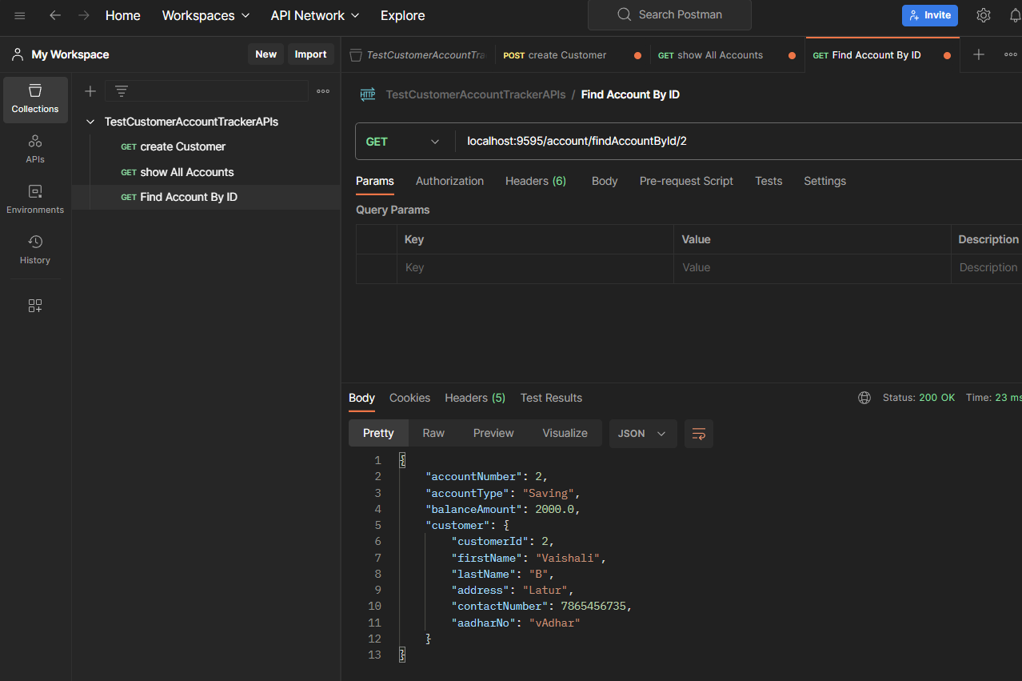

1. FIND ACCOUNT BY TYPE

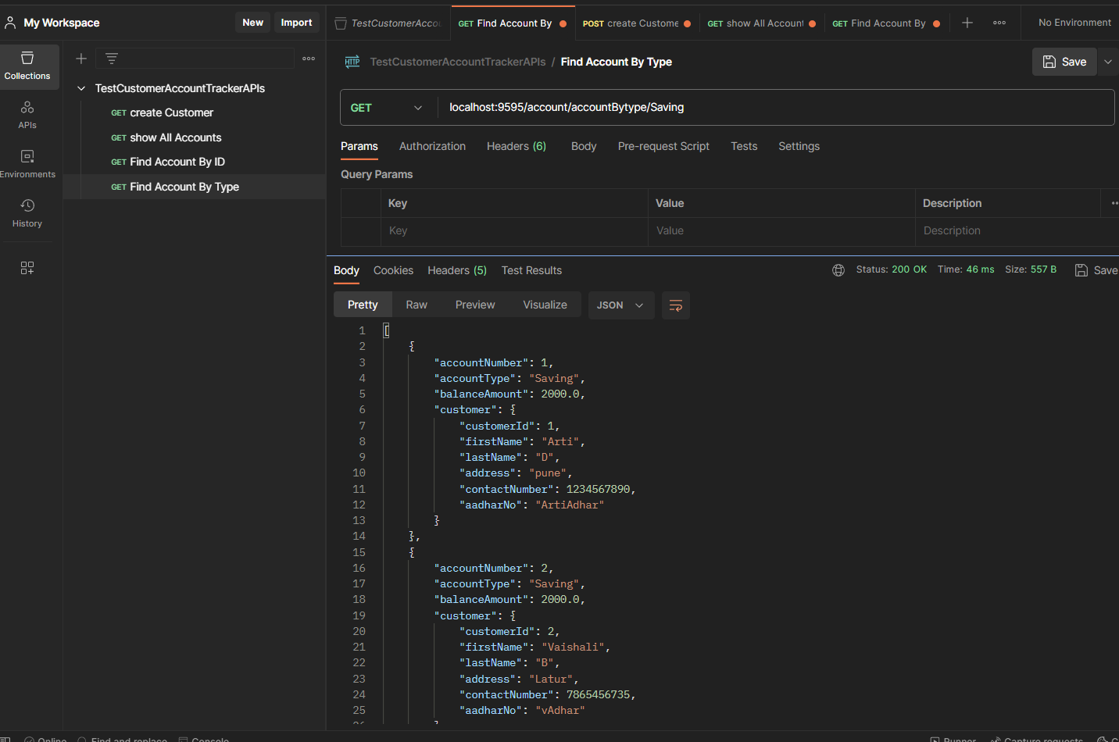

1. Get BAlance

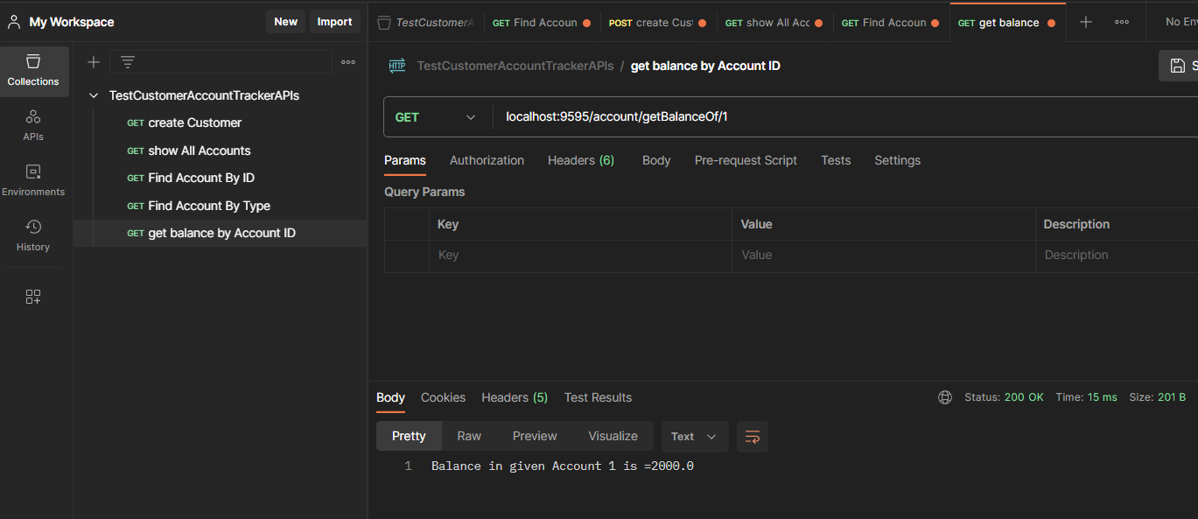

1. FundTransferfromOneAccountToAnother

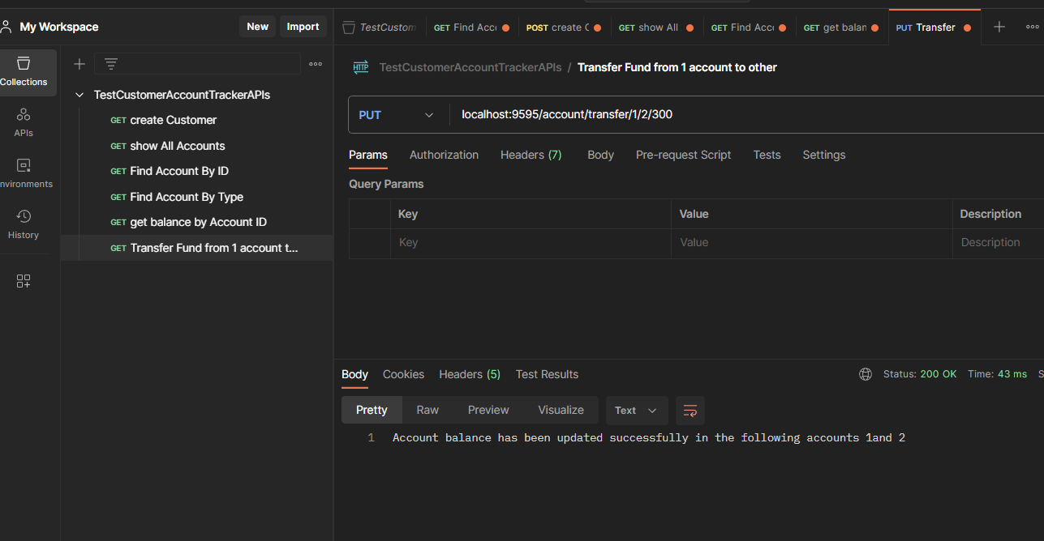

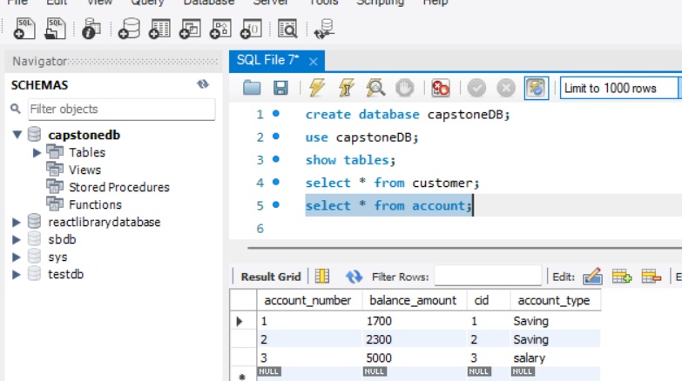

1. DEPOSITE MONEY

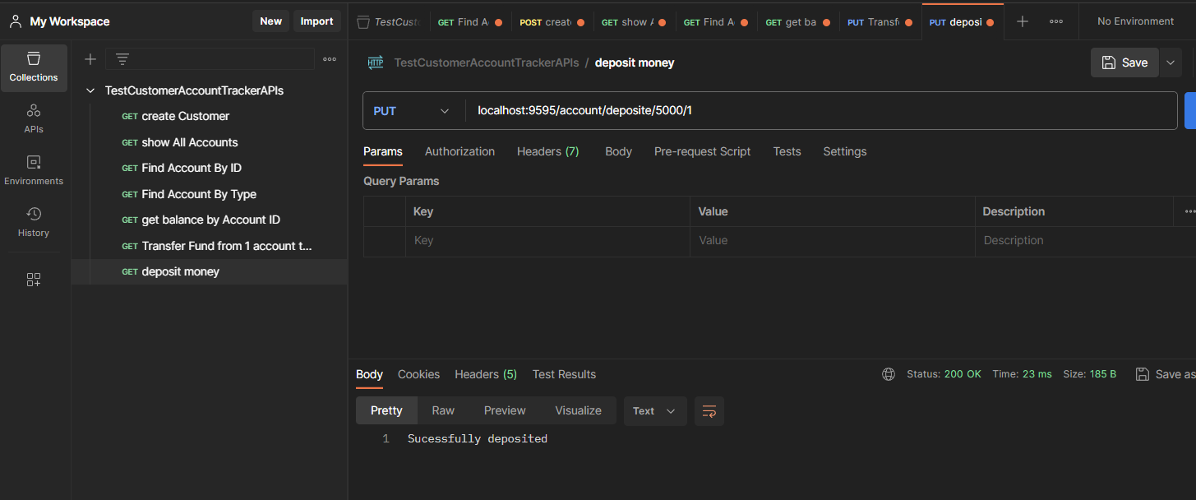

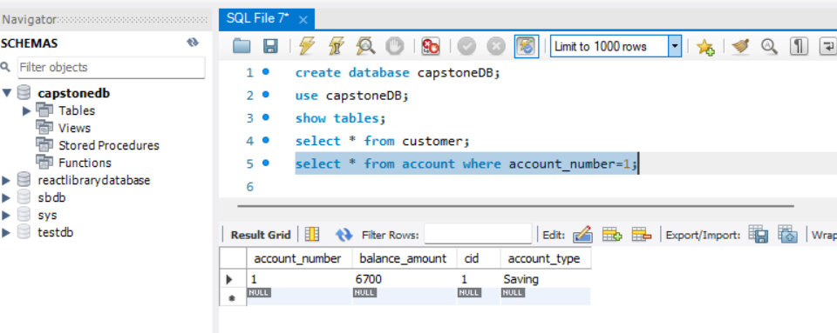

1. WITHDRAW MONEY

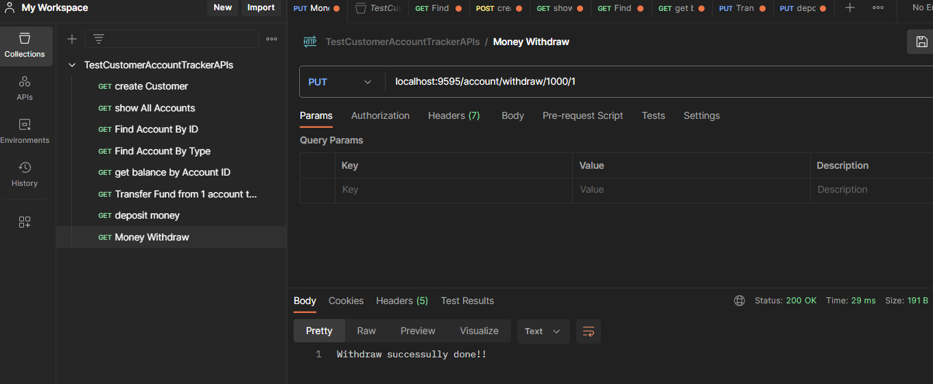

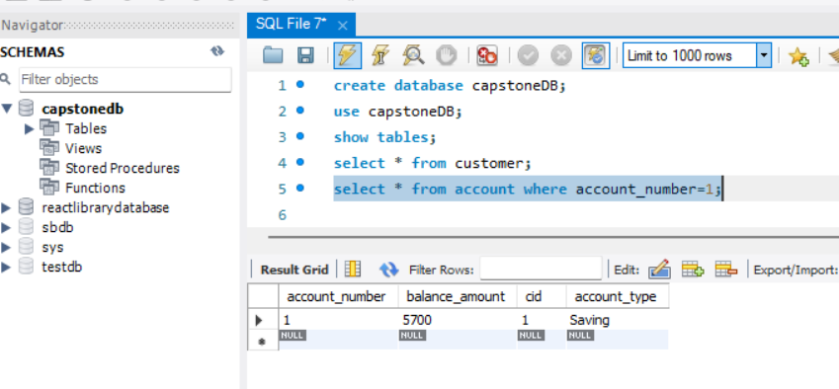

1. Update details

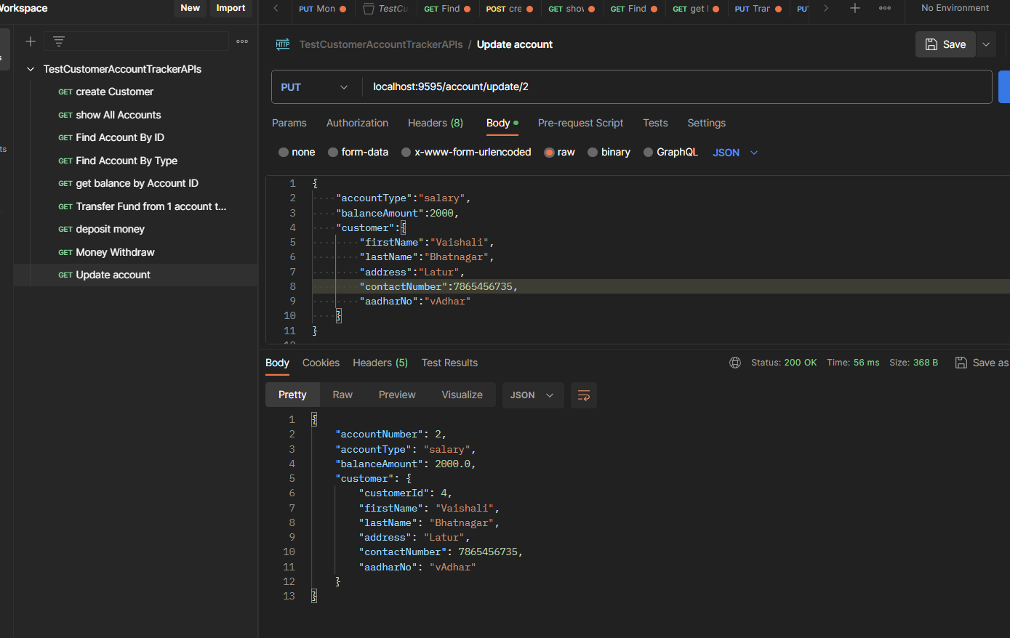

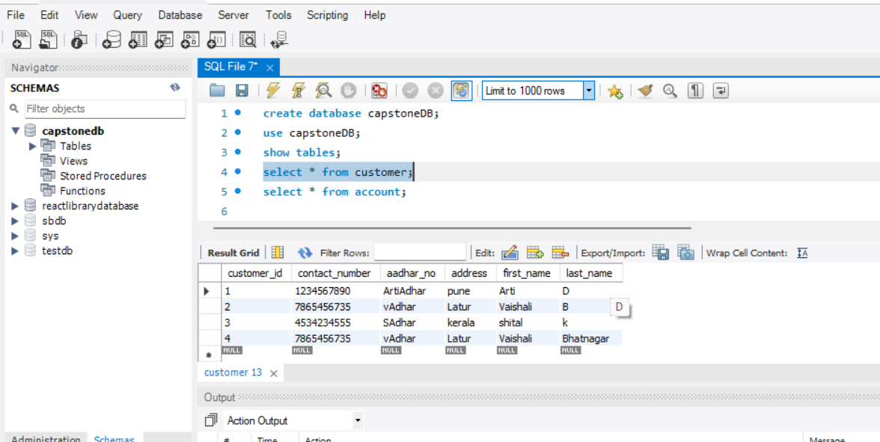

1. Delete by account number

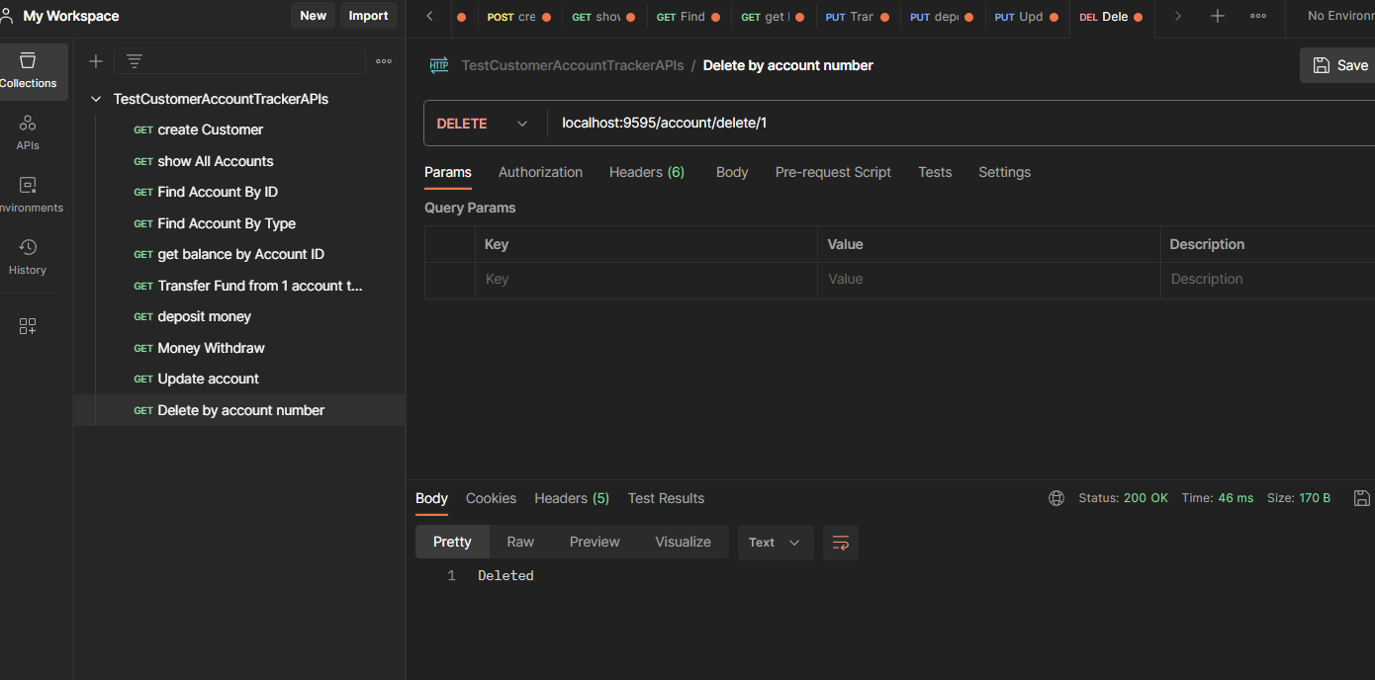

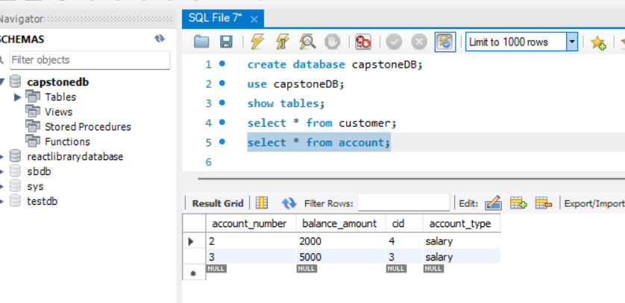

**CUSTOMER**:

1. GetAll

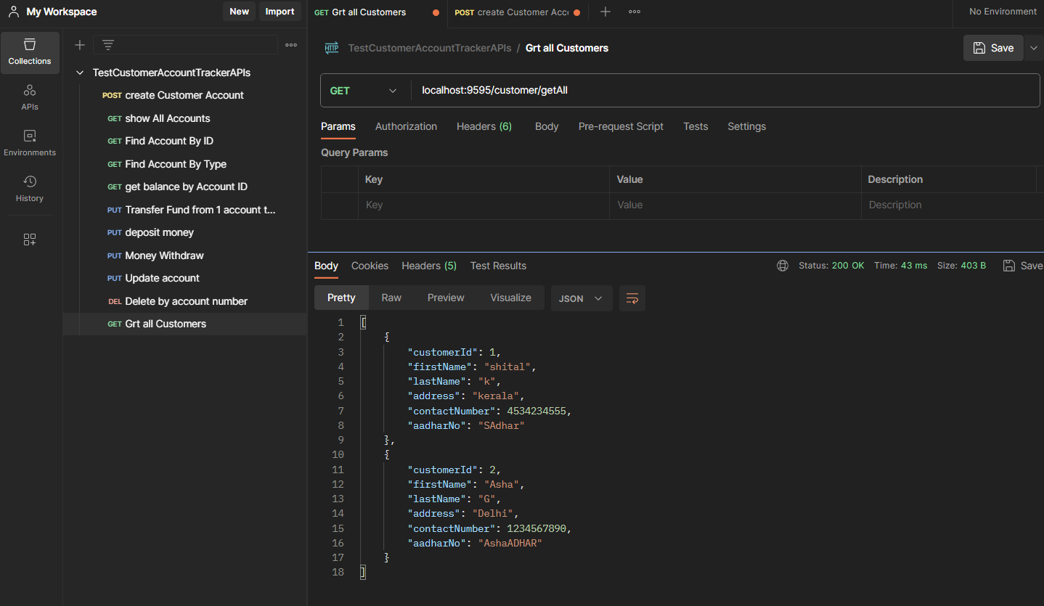

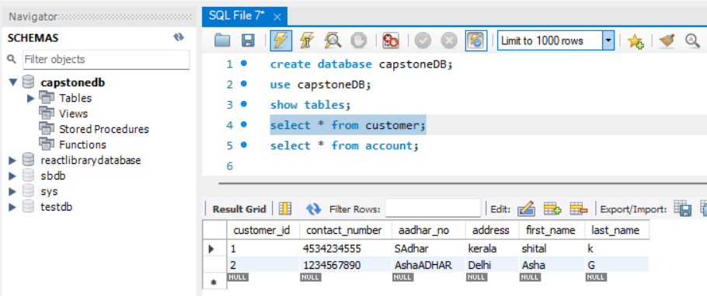

1. Update Customer

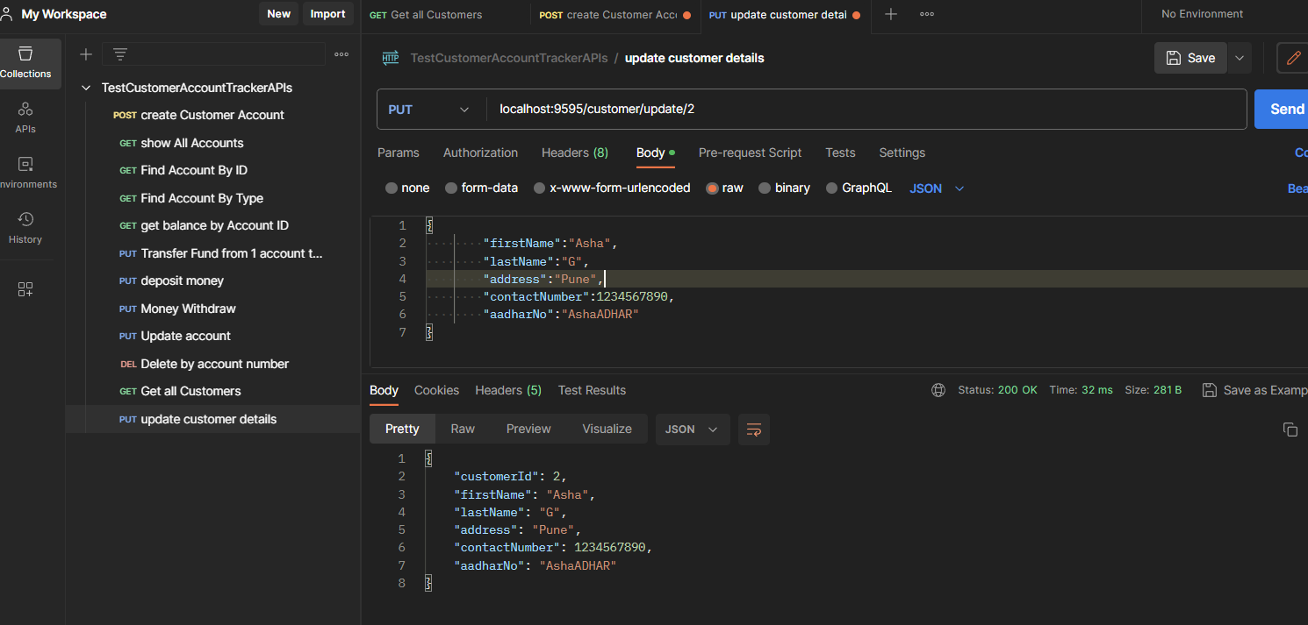

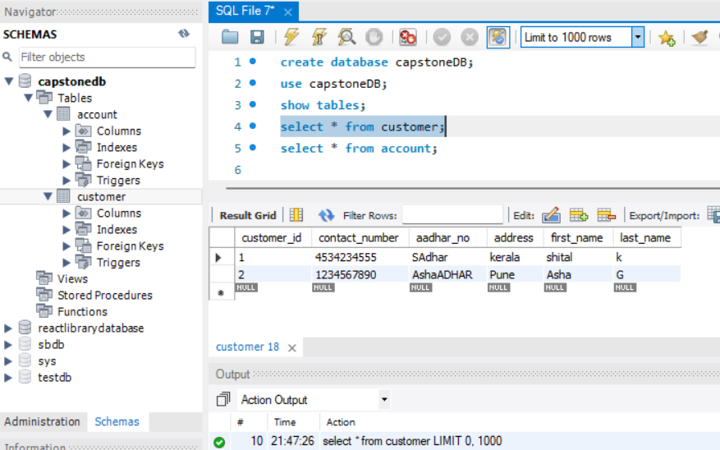

1. Find Customer with ID

